**REGINA CAELI GIRLS HIGH SCHOOL -KARINGA**

**231**

**Biology**

**Form 4**

**Term II opener 2022**

**Time: 2½** **Hrs**

**Name………………………………………….Adm………………..**

**Class………..**

**Instructions**

* **Write your name, class and admission number as required.**
* **This paper consists of …… printed pages.**
* **Ensure all the requisite pages are printed.**
* **Answer all questions in the spaces provided.**
* **All answers should be written in English.**
* **Use blue or black pen.**

**EXAMINER’S USE ONLY**

|  |
| --- |
| **100** |

1. Other than having many features in common, state 1 other characteristics of species (1 mark) ………………………………………………………………………………………………… 2. An organism is with an exoskeleton; segmented body; two pairs of legs per segment; a pair of eyes and pair of short antennae. Which phylum does the organism belong? (1 mark) ………………………………………………………………………………………………………3. State two functions of cell sap (2 mark) ……………………………………………………………………………………………………………… ……………………………………………………………………………………………………… 4. Which organelle would be abundant in; [2mark]

(a) Skeletal muscles. …………………………………………………………………………………………………… (b) Palisade cells ……………………………………………………………………………………………………………… ……………………………………………………………………………………………………… 5. (a) What is the formular for calculating linear magnification of a specimen when using a hand lens (1 mark) ……………………………………………………………………………………………………………… ……………………………………………………………………………………………………… (b) Give a reason why staining is necessary when preparing specimen (1 mark)

……………………………………………………………………………………………………………… ………………………………………………………………………………………………………6. State two functions of golgi apparatus (2marks) ……………………………………………………………………………………………………………… ………………………………………………………………………………………………………7. State the functions of the following parts of a light microscope

a) Mirror (1 mark) ……………………………………………………………………………………………………………… ………………………………………………………………………………………………………………

b) Body tube (1 mark) ………………………………………………………………………………………………………………………………………………………………………………………………………………

8. Explain what would happen to red blood cells if they were placed in a concentrated salt solution (2 marks) ……………………………………………………………………………………………………………… ……………………………………………………………………………………………………

9. Give a reason for each of the following

a) A mature plant cell does not lose its shape even after loosing water. (1 mark) ……………………………………………………………………………………………………………… ……………………………………………………………………………………………………… b) Xylem vessels do not collapse even when they do not contain water (1 mark) ……………………………………………………………………………………………………………… ………………………………………………………………………………………………………10. Outline three roles of active transport in human body (3 marks) ……………………………………………………………………………………………………………… ……………………………………………………………………………………………………………… ……………………………………………………………………………………………………… 11. State the importance of osmosis in plants (3 marks)

……………………………………………………………………………………………………………… ……………………………………………………………………………………………………………… ………………………………………………………………………………………………………12. Distinguish between haemolysis and plasmolysis (2 marks) ……………………………………………………………………………………………………………… ……………………………………………………………………………………………………………… ………………………………………………………………………………………………………

13. The graph below shows the effect of substrate concentration on the rate of enzyme reaction

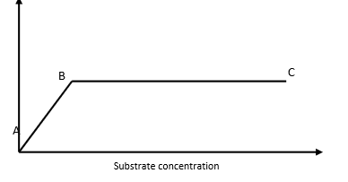

Account for the shape of the graph between

a) A and B (2 marks)

……………………………………………………………………………………………………………… ……………………………………………………………………………………………………………… ……………………………………………………………………………………………………… b) B and C (2 marks) ……………………………………………………………………………………………………………… ………………………………………………………………………………………………………14. a) Name one defect of circulatory system in human beings (1 mark) ……………………………………………………………………………………………………………… …………………………………………………………………………………………………… b) State three functions of blood other than transport (3 marks) ………………………………………………………………………………………………………………………………………………………………………………………………………………………………………………………………………………………………………………………15. State two ways in which the root hairs are adapted to their function (2 marks)

……………………………………………………………………………………………………………… ………………………………………………………………………………………………………

16. State three structural differences between arteries and veins (3 marks) ……………………………………………………………………………………………………………… ……………………………………………………………………………………………………………… ……………………………………………………………………………………………………………… ………………………………………………………………………………………………………17. The number of stomata on the lower surface of two leaves from plant species A and B were counted under the field of view of a light microscope. The results were as shown below.

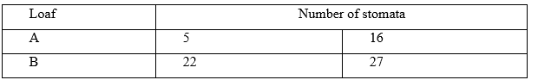

(a) Which of the two leaves would be expected to have lower rate of transpiration (1 mark) ……………………………………………………………………………………………………………… ……………………………………………………………………………………………………………… …………………………………………………………………………………………………

(b) Give a reason for your answer in (a) above (1 mark) ……………………………………………………………………………………………………………… ……………………………………………………………………………………………………… 18. a) What is wilting? (1 mark) ……………………………………………………………………………………………………………… ……………………………………………………………………………………………………………… ………………………………………………………………………………………………………b) Explain how an increase in temperature affects the rate of diffusion (2 marks) ……………………………………………………………………………………………………………… ……………………………………………………………………………………………………………… …………………………………………………………………………………………………….

19. The diagram below represents a fine structure of a generalized animal cell as seen under an electron microscope.

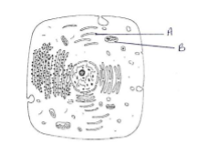

1. Name the parts labeled A and B

A

B

b) How is the structure labeled B adapted to junction (2 marks) ………………………………………………………………………………………………………… ………………………………………………………………………………………………………… ……………………………………………………………………………………………………… 20. a) State three observable features found in the class mammalian only (3 marks) …………………………………………………………………………………………………….. ……………………………………………………………………………………………………………………………………………………………………………………………………………………………………………………………………………………………………………………… ………………………………………………………………………………………………………b) Name the phylum whose members possess notochord (1 mark) ……………………………………………………………………………………………………… ……………………………………………………………………………………………………… 21. a) Explain how sex determine a person’s energy requirements (2 marks) ……………………………………………………………………………………………………… ………………………………………………………………………………………………………………………………………………………………………………………………………………b) What is the role of mucus in the stomach (2 marks) ……………………………………………………………………………………………………………… ……………………………………………………………………………………………………

22. A cell was magnified 100 times using a light microscope whose eye piece lens magnification was x 10. What was the magnification of the objective lens show your working. (3 marks)

23. Explain how protogyny prevents self-pollination (2 marks) ……………………………………………………………………………………………………………… ……………………………………………………………………………………………………… 24. A student used 1 m2 quadrant to determine the population of star grass in a 10m x 20m plot. He collected the data and recorded it as shown in the table below.

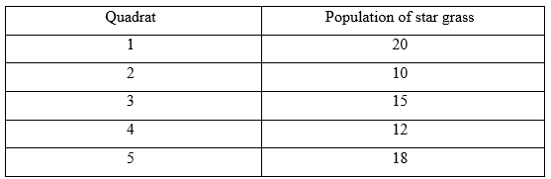

Using the data above, determine the total population of the star grass (3 marks) ……………………………………………………………………………………………………………… ……………………………………………………………………………………………………………… ………………………………………………………………………………………………………25. a) What causes the following diseases?

i) diabetes melitus (1 marks) ……………………………………………………………………………………………………………… ……………………………………………………………………………………………………… ii) Diabetes inspidus (1 mark) ……………………………………………………………………………………………………………… ……………………………………………………………………………………………...

b) An individual shows the symptoms of diabetes mellitus. How would you determine in the school laboratory whether they are positive for the condition (3 marks) ……………………………………………………………………………………………………………… ……………………………………………………………………………………………………………… …………………………………………………………………………………………………… 26. Study the bio-chemical reactions given below and answer the questions that follow;

Glucose + glucose I → water + maltose

Maltose + water II → Glucose + glucose

a) i) Name the enzyme involved in the process II (1 mark) ……………………………………………………………………………………………………………… ……………………………………………………………………………………………………… ii) Name the processes I and II

I _____________________________________ (1 mark)

II ____________________________________ (1 mark)

b) Explain how the process marked II can be carried out in a laboratory. (1 mark) ……………………………………………………………………………………………………………… ………………………………………………………………………………………………………

27. The diagram below represents transverse section of an ovary of a certain flower.

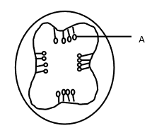

a) i) Name the structure labeled A (1 mark) ……………………………………………………………………………………………………………… ………………………………………………………………………………………………………

ii) Name the type of placentation illustrated in this diagram (1 mark)

……………………………………………………………………………………………………………… ……………………………………………………………………………………………………… b) Give an example of a plant whose flowers have the type of placentation named in a. (ii) above (1 mark) ……………………………………………………………………………………………………………… ……………………………………………………………………………………………………… 28. State three functions of water in seed germination (3 marks) ……………………………………………………………………………………………………………… ……………………………………………………………………………………………………………… ……………………………………………………………………………………………………… 29.

5 C51H98O6 + 145O2 →102CO2+ 98H2O

The above equation shows an oxidation reaction of a food substance

a) What do you understand by the term respiratory quotient? (1 mark) ……………………………………………………………………………………………………………… ……………………………………………………………………………………………………… b) Determine the respiratory quotient of the oxidation of the food substance (1 mark)

c) Identify the food substance (1 mark) ……………………………………………………………………………………………………………… ………………………………………………………………………………………………………

30. Describe 4 evidences which show that evolution has taken place (20 marks)

………………………………………………………………………………………………………………………………………………………………………………………………………………………………………………………………………………………………………………………………………………………………………………………………………………………………………………………………………………………………………………………………………………………………………………………………………………………………………………………………………………………………………………………………………………………………………………………………………………………………………………………………………………………………………………………………………………………………………………………………………………………………………………………………………………………………………………………………………………………………………………………………………………………………………………………………………………………………………………………………………………………………………………………………………………………………………………………………………………………………………………………………………………………………………………………………………………………………………………………………………………………………………………………………………………………………………………………………………………………………………………………………………………………………………………………………………………………………………………………………………………………………………………………………………………………………………………………………………………………………

………………………………………………………………………………………………………………………………………………………………………………………………………………………………………………………………………………………………………………………………………………………………………………………………………………………………………………………………………………………………………………………………………………………………………………………………………………………………………………………………………………………………………………………………………………………………………………………………………………………………………………………………………………………………………………………………………………………………………………………………………………………………………………………………………………

………………………………………………………………………………………………………………………………………………………………………………………………………………………………………………………………………………………………………………………………………………………………………………………………………………………………………………………………………………………………………………………………………………………………………………………………………………………………………………………………………………………………………………………………………………………………………………………………………………………………………………………………………………………………………………………………………………………………………………………………………………………………………………………………………………

………………………………………………………………………………………………………………………………………………………………………………………………………………………………………………………………………………………………………………………………………………………………………………………………………………………………………………………………………………………………………………………………………………………………………………………………………………………………………………………………………………………………………………………………………………………………………………………………………………………………………………………………………………………………………………………………………………………………………………………………………………………………………………………………………………